**A PROJECT REPORT**

***Submitted by***

**CH. GEETHIKA NAGA SUSHMA**

**G. SAI PADMAJA**

**G. HEMA SRI**

**CH. JAHNAVI**

***in partial fulfillment for the award of the*** ***degree of***

**BACHELOR OF TECHNOLOGY**

***in***

**INFORMATION TECHNOLOGY**



**SHRI VISHNU ENGINEERING COLLEGE FOR WOMEN**

**(AUTONOMOUS)**

**BHIMAVARAM, 534 202. ANDHRA PRADESH**

**2020-21**

I

**Table of Contents**

INTRODUCTION

System Requirements Specification

Software Requirements

Hardware Requirements

PROBLEM STATEMENT

SCOPE FOR SYSTEM

MODULES

INTRODUCTION

MAIN PAGE

LOGIN AND SIGNUP

DRIVER SIGNUP

DRIVER LOGIN

DRIVER CATEGORY

DRIVER…………………………………………………………………………………………………………………………………………….

EDIT

UPDATION

DEALER

DEALER SIGNUP…………………………………………………………………………………………………

DEALER LOGIN………………………………………………………………………………………………………………………………………………….

**System Requirements Specification**

**Software Requirements**

* **Hypertext Mark**-up Language(HTML)
* **Cascading Style Sheets(**CSS)
* **PHP**
* **MySQL database**
* **Apache**

**Hardware Requirements**

* + **Operating system: Microsoft windows 7 or above.**
* **Processor**: Intel core i5/i7
* **RAM**: 8+ GB
* **Space on hard disk**: 1TB

**PROBLEM STATEMENT**

Use Case:

You are expected to build a web application where dealers can book drivers through the application

for transporting their goods. Your application is expected to have certain features which are listed

down below:

There should be 2 types of user logins and signups:

a. As the Dealer

- For new dealer signup, there should be a signup form which will ask the

following details - Name, Mobile Number, Nature of Material, Weight of

Material, Quantity, City and State.

- This user can book the drivers from the list of drivers in his dashboard whose

interested routes are the same as the dealer's location (State and City).

For eg: If the dealer’s location is Madhya Pradesh-Indore , all the drivers going

from/to Madhya Pradesh-Indore should display in the dealers dashboard

- Dealers can also search Driver from (State and City) to (State and City).

b. As the Driver

- For new drivers to sign up, there should be a sign up form which will ask the

following details- Name, Age, Truck Number, Mobile Number, Truck Capacity,

Transporter Name, Driving Experience, 3 Interested routes (From- state and

city/To- state and city).

- After login, this user can only see the dealers who have booked for his services.

1. Login via

● Username - password

● Login using OTP through the mail. This means OTP should be sent to mail ID.

2. Dealer Home screen should show the list of drivers going through the same route as the

dealer's State and City which means the dealer should be able to see the drivers who have

mentioned the same interested routes as the dealer’s State and City.

3. Drivers Home screen should show the list of Dealers that have booked them

**SCOPE FOR SYSTEM**

* + Signup **–** They should create an account in the website dri_signup - driver

de_signup- dealer

* Login -There is login to enter this system based on type of user

**MODULES**

**INTRODUCTION**

System implementation is the construction of the system and the delivery of it into production. Interfaces and user manual of the system are included in this chapter.

**MAIN PAGE**

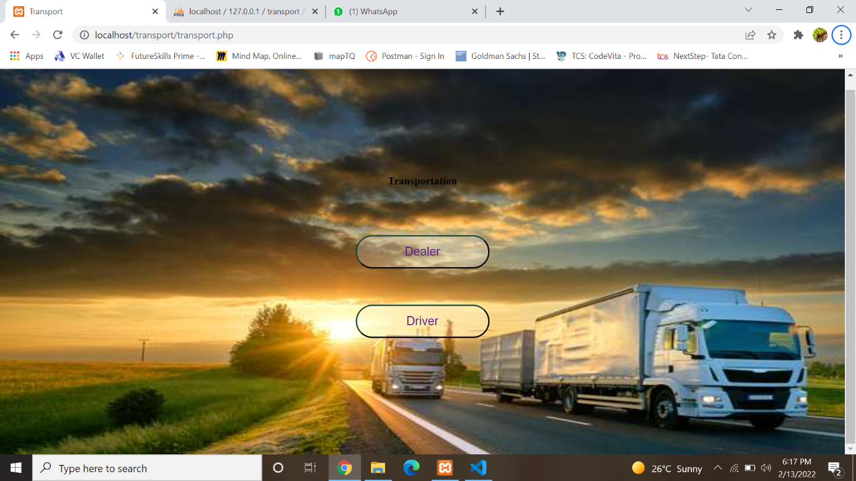

**LOGIN AND SIGNUP**

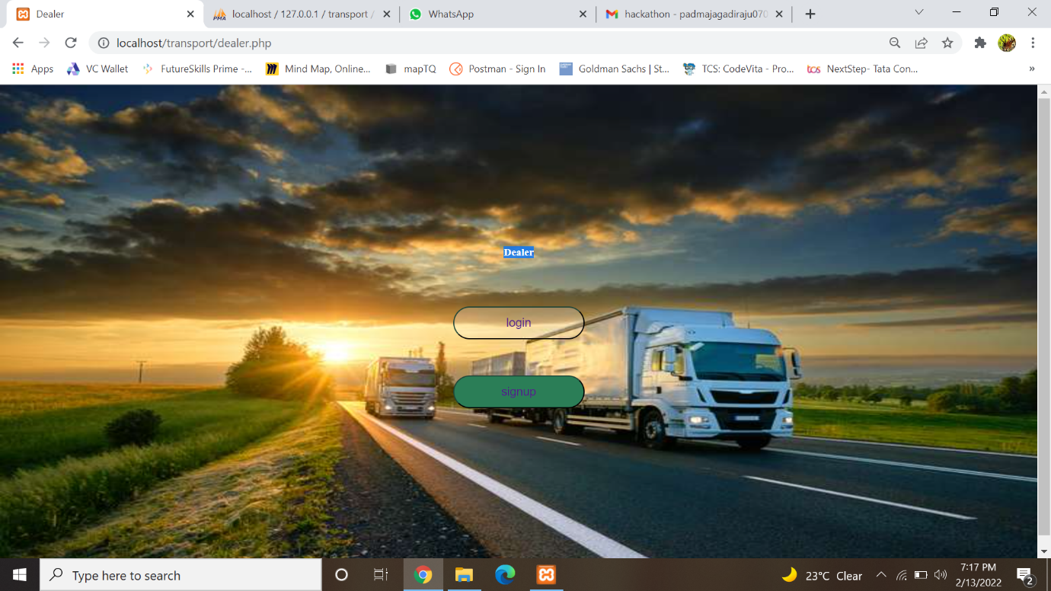

**DRIVER SIGNUP**

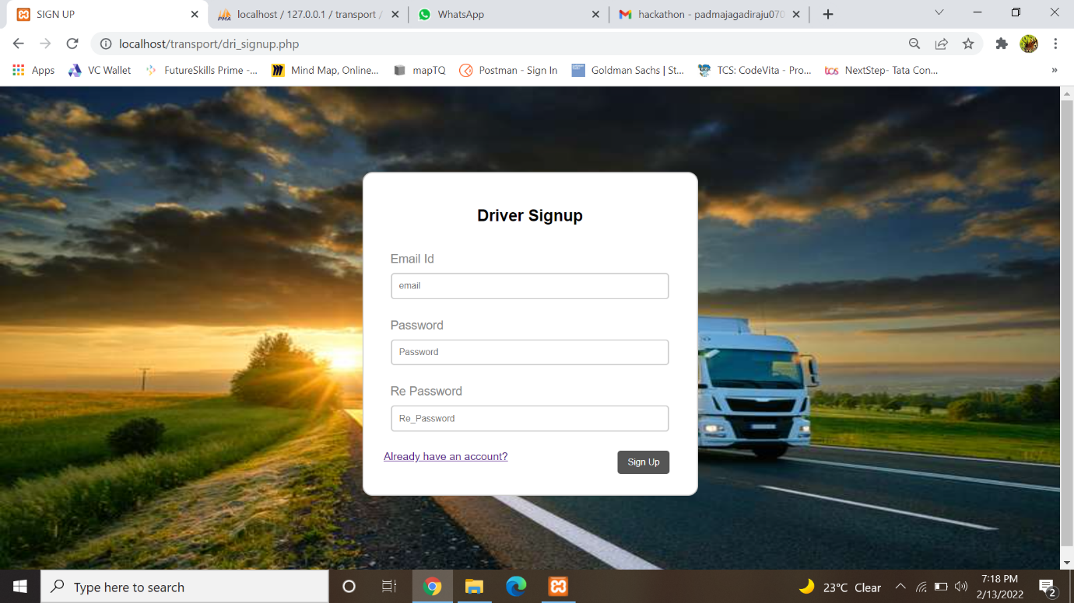

**DRIVER DETAILS**

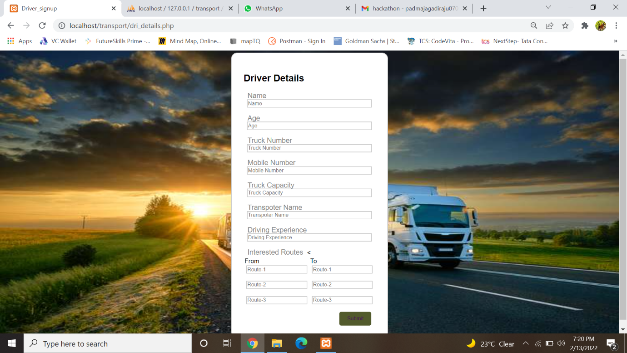

**DRIVER LOGIN**

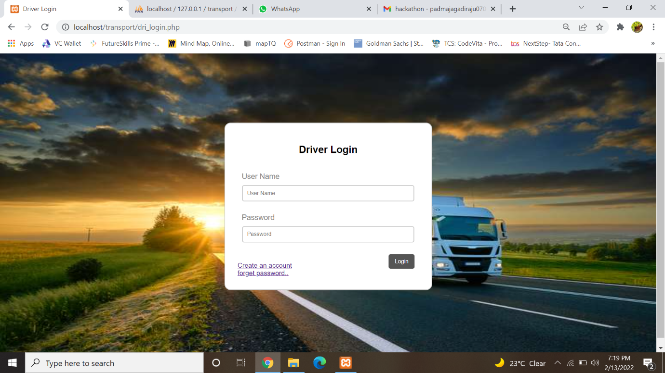

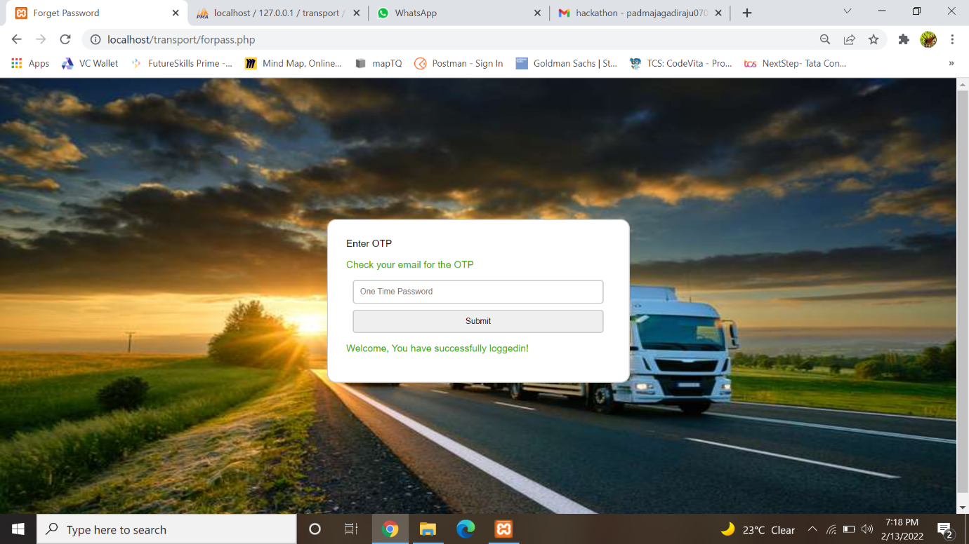

**DEALER SIGNUP**

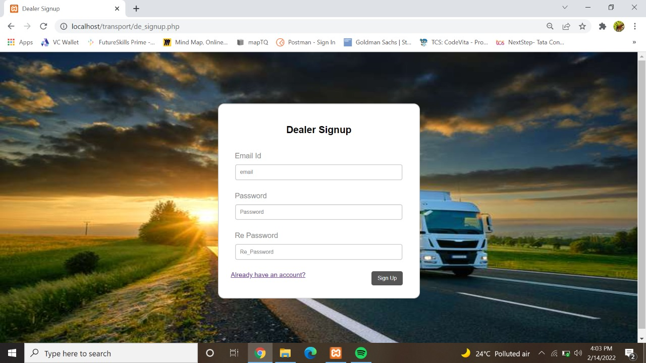

**DEALER DETAILS**

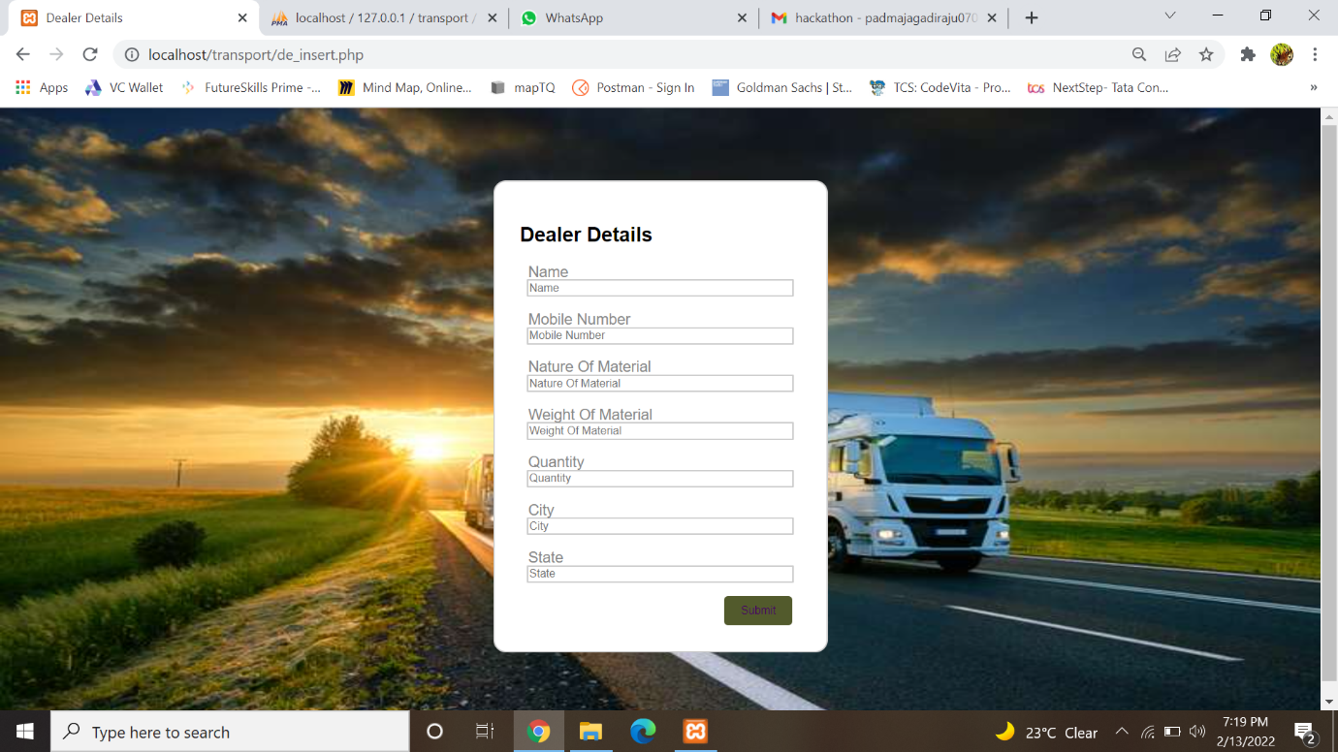

**DEALER LOGIN**

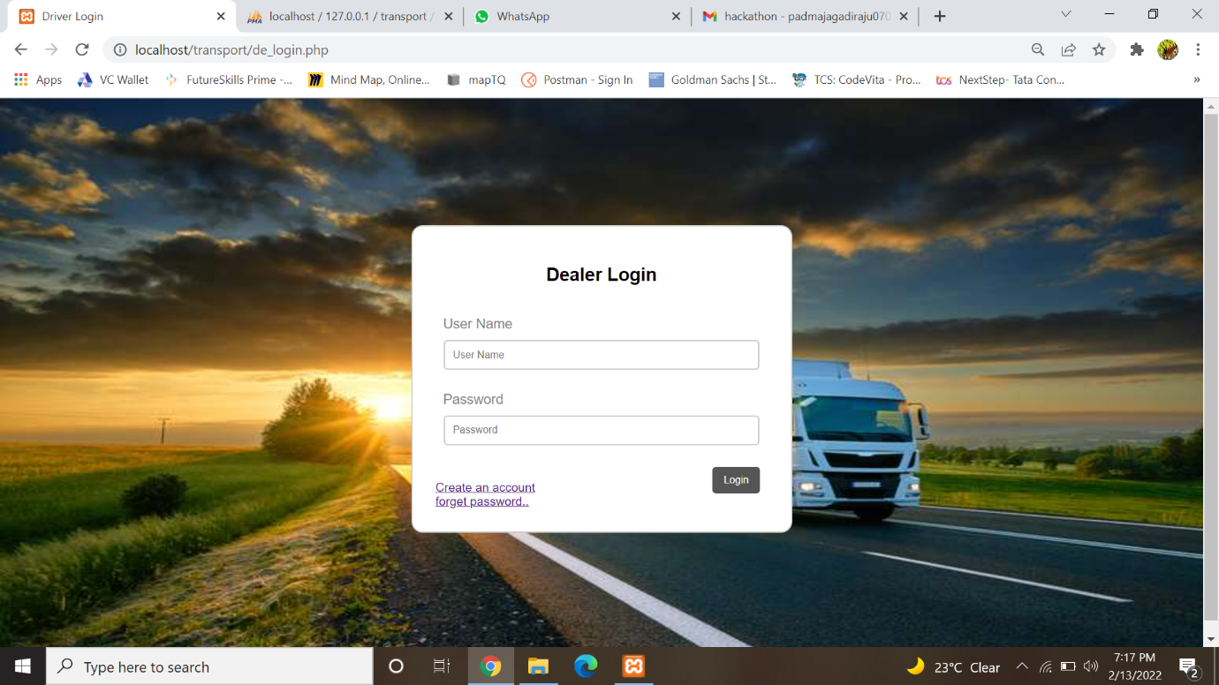



**DRIVER UPDATION**

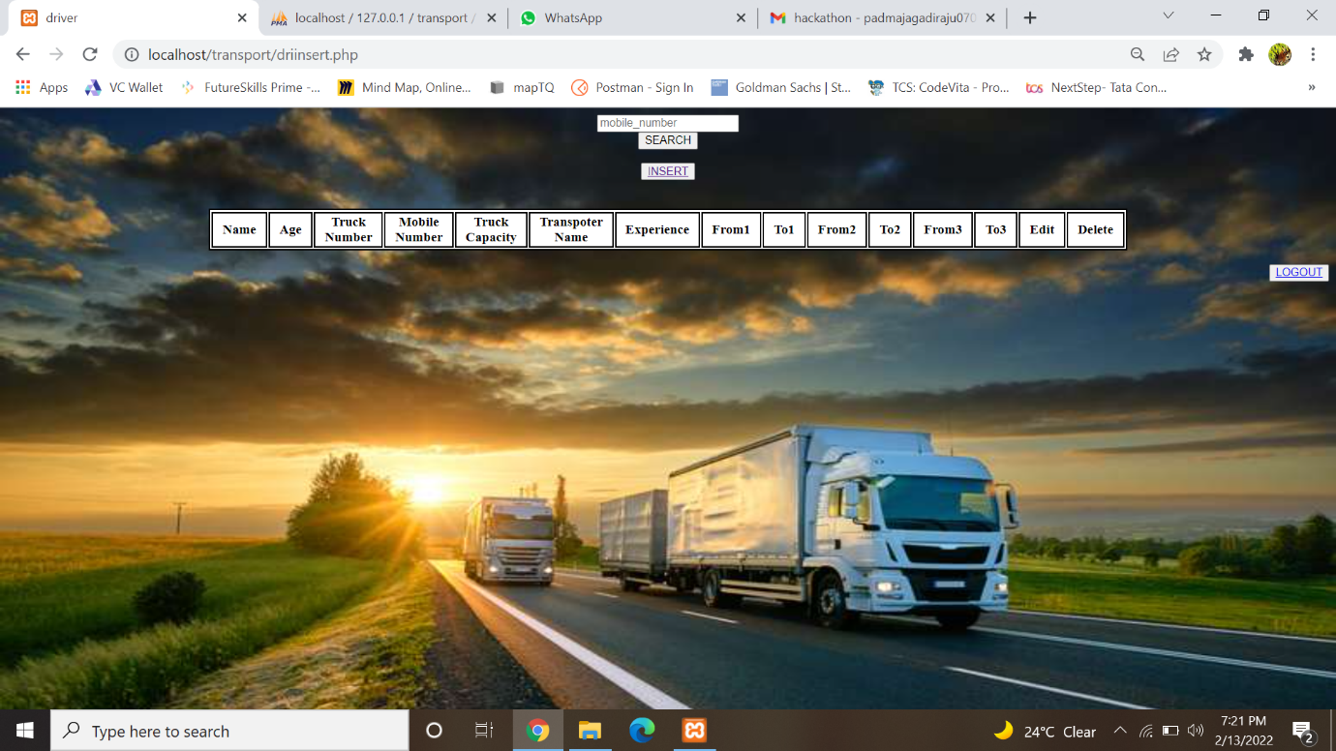

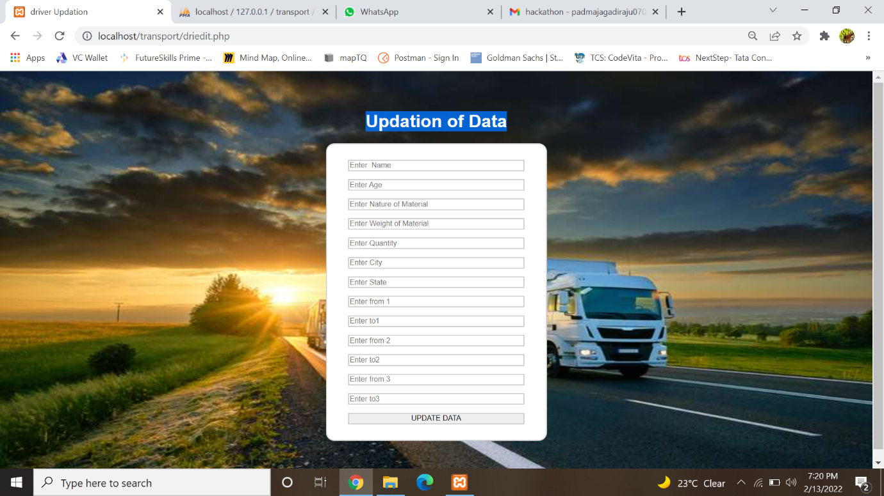

**DEALER UPDATION**

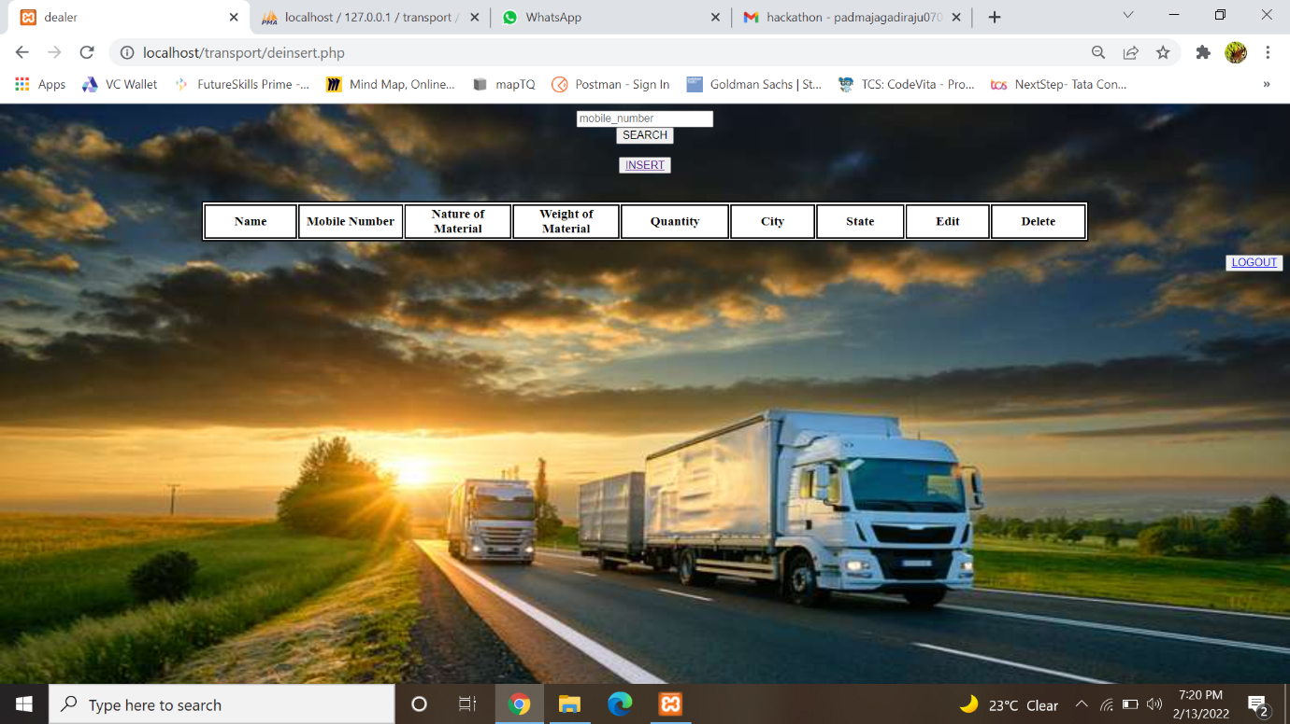

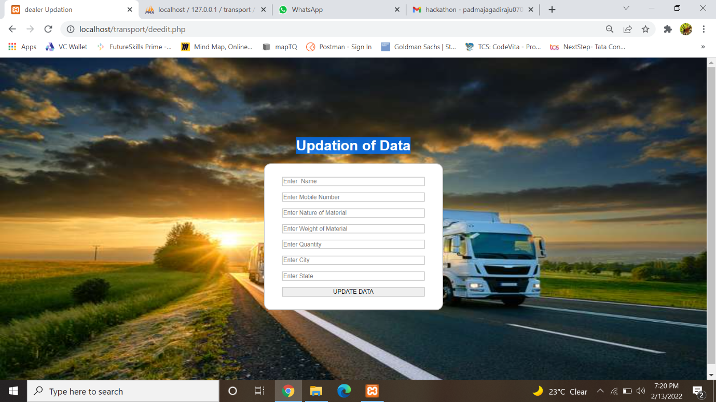

**DATABASES**

**DRIVER LOGIN**

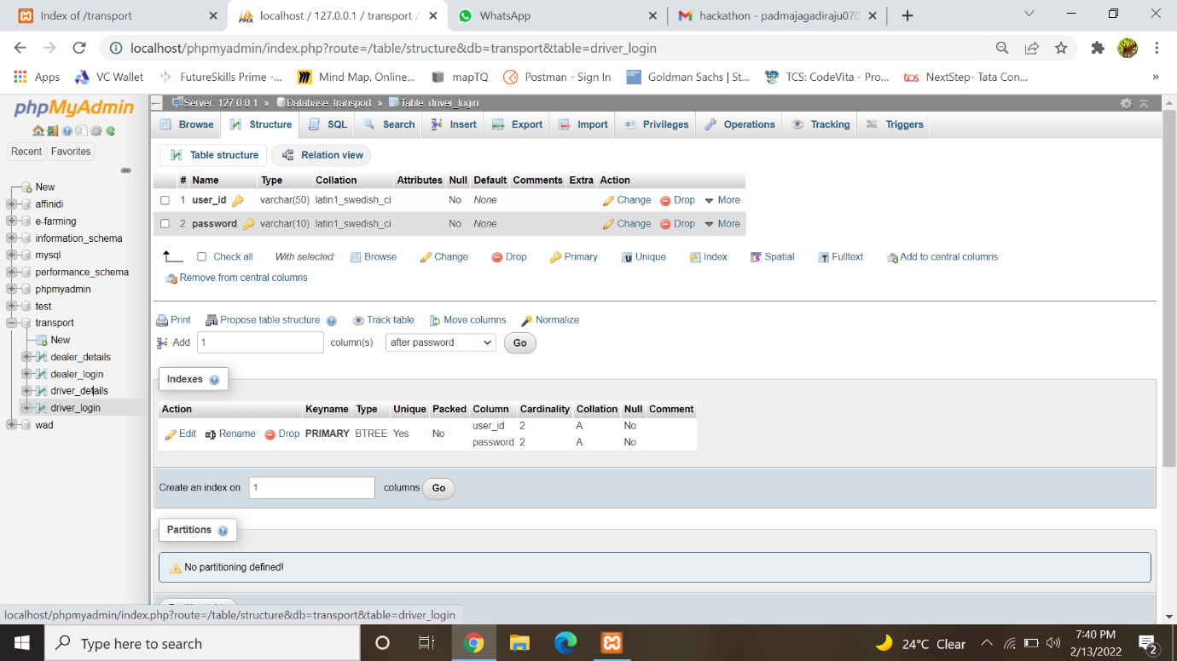

**DRIVER DETAILS**

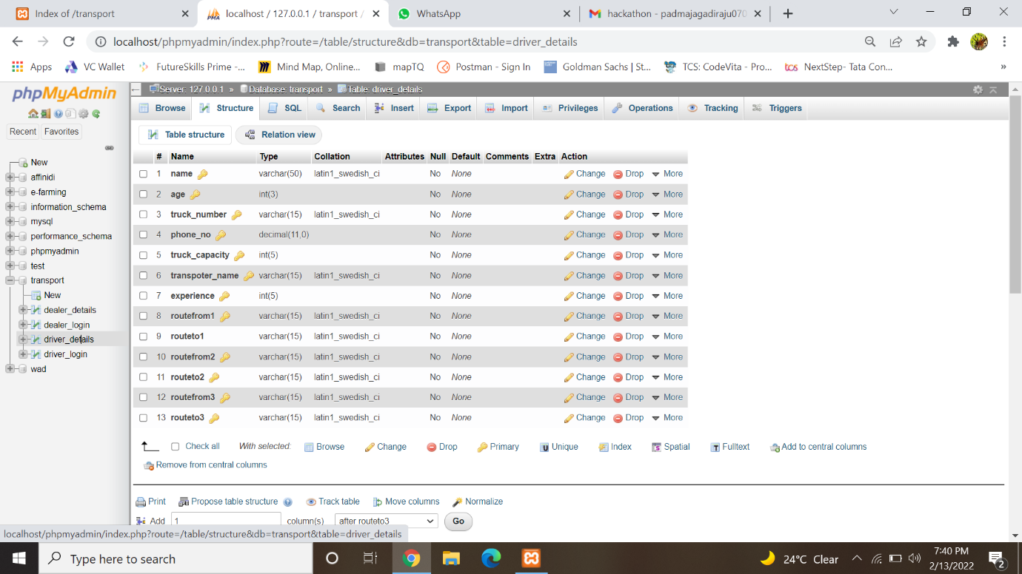

**DEALER LOGIN**

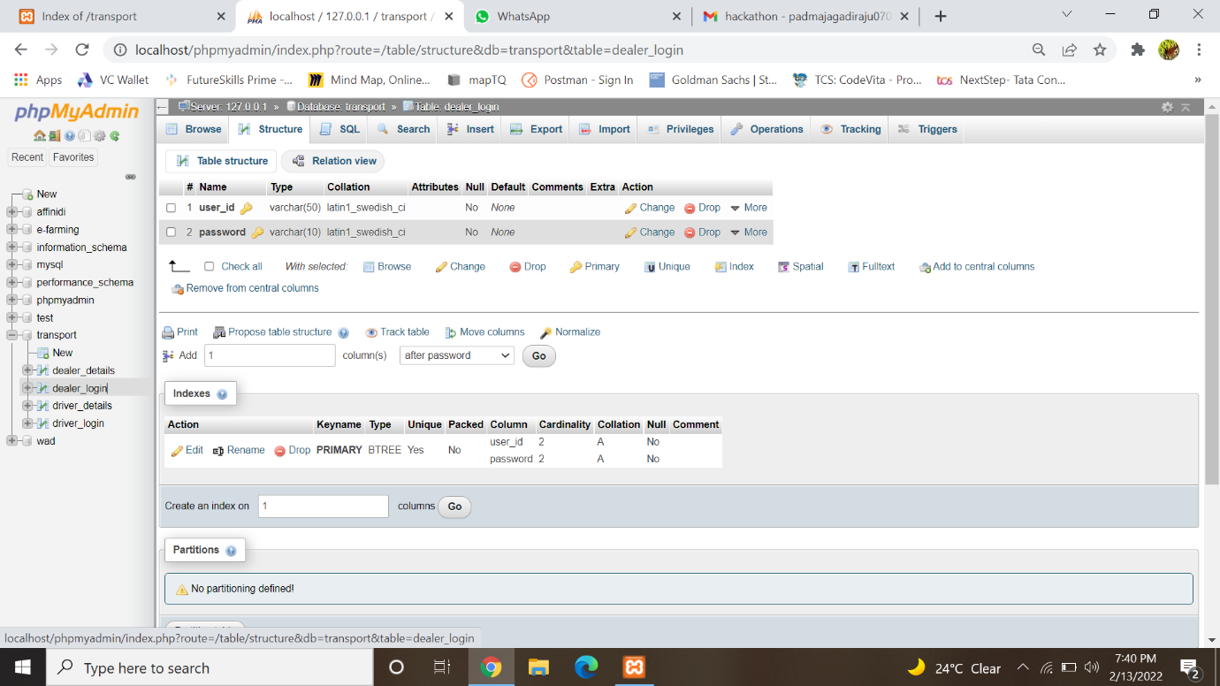

**DEALER DETAILS**

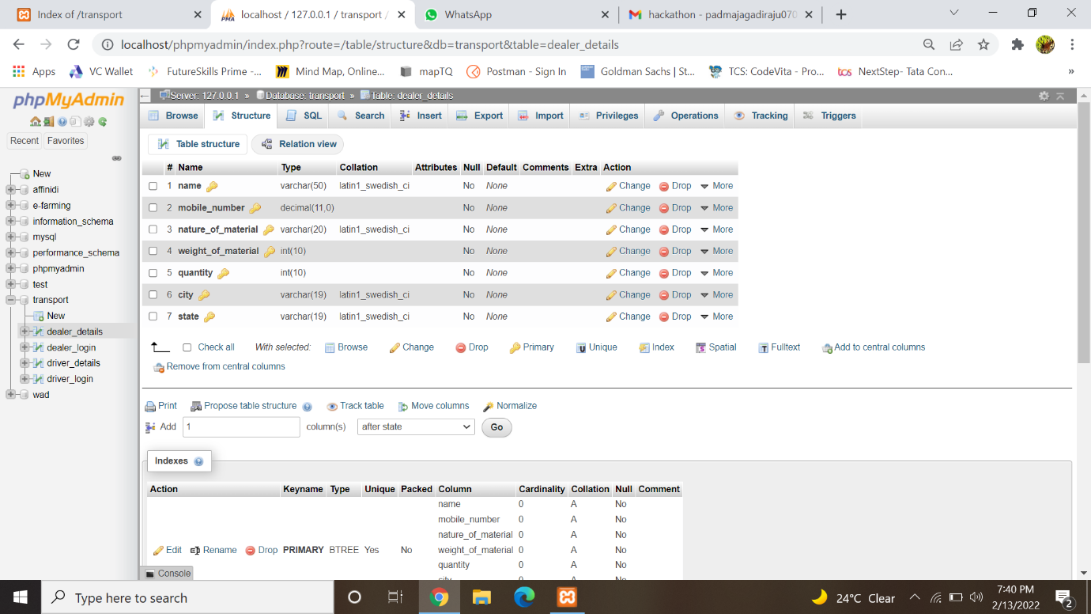

**CONCLUSION:**

**Front end and backend database are created few frontend and backend connections are done.**